Extension of Breast Cancer Prediction Model using Random Forest
Rida Mohammed

Abstract: Breast cancer early detection can save lives, but accurate diagnosis remains challenging. Previous work showed that Support Vector Machine (SVM) outperformed a Decision Tree classifier (91.92% vs. 87.12% accuracy). This study extends the work by introducing a Random Forest classifier using the same dataset, preprocessing, and a 75–25 train-test split. Hyperparameter tuning, balanced class weights, and 5-fold cross-validation were applied.
The tuned Random Forest matched SVM performance with 97.2% accuracy and 0.996 AUC, while the balanced Random Forest achieved the best test results with 97.9% accuracy, 96.30% recall, and 0.9986 AUC. However, cross-validation showed that balanced SVM achieved higher average accuracy. These findings suggest that balanced Random Forest improves test performance, while SVM remains the more stable model overall.
A. Introduction
The original study demonstrated that the Support Vector Machine (SVM) achieved higher classification accuracy (91.92%) compared to the Decision Tree (87.12%) in breast cancer diagnosis. However, ensemble learning methods such as Random Forest have been shown to improve predictive performance by reducing variance and enhancing generalization. Therefore, this work extends the original model by incorporating a Random Forest classifier and evaluating its effectiveness on the same dataset.
We have used the same Kaggle data repository as the original paper. This dataset consists of the features labeled as malignant and benign. Some of the features used in classification of breast cancer are breast radius mean, texture mean, perimeter mean, texture and so on. The dataset consists of 569 sample breast cancer instances or rows and 30 features or columns.
B. Methodology
To ensure a fair comparison with the original study, the same dataset and preprocessing steps were followed, including feature selection, normalization, and a 75%–25% train-test split.
The following improvements were introduced:
1. Hyperparameter tuning of Random Forest using grid search techniques.
2. Handling class imbalance using balanced class weights.
3. Cross-validation (5-fold) for robust evaluation.
4. Evaluation metrics including accuracy, precision, recall, and ROC-AUC.
C. Results
1) Baseline Comparison:
Model | Accuracy | Precision | Recall | AUC Score
SVM | 0.972 | 0.9630 | 0.9630 | 0.9967
Decision Tree (Tuned) | 0.951 | 0.9273 | 0.9444 | 0.9433
Random Forest (Tuned) | 0.972 | 0.9808 | 0.9444 | 0.9958
Table I: Comparing initial model performances
The results indicate that the tuned Random Forest achieves performance comparable to SVM in terms of accuracy and AUC score.
2) Cross-Validation Analysis
Model | Mean Accuracy | Std. Deviation
SVM (RBF Kernel) | 0.9741 | 0.0137
Decision Tree (Tuned) | 0.9319 | 0.0117
Random Forest (Tuned) | 0.9624 | 0.0262
Table II: Comparing model performance on cross validation
SVM achieves the highest mean accuracy. Random Forest demonstrates competitive performance with acceptable variance.
3) Effect of Class Balancing
Model | Accuracy | Precision | Recall | AUC Score
SVM (Balanced) | 0.958 | 0.9286 | 0.9630 | 0.9969
Decision Tree (Balanced) | 0.951 | 0.9273 | 0.9444 | 0.9498
Random Forest (Balanced) | 0.979 | 0.9811 | 0.9630 | 0.9986
Table III: Evaluating the effect of class balancing on Random Forest
The balanced Random Forest outperforms all other models in terms of accuracy, recall, and AUC score.
Model | Mean Accuracy | Std. Deviation
SVM (Balanced) | 0.9741 | 0.0203
Decision Tree (Balanced) | 0.9178 | 0.0269
Random Forest (Balanced) | 0.9554 | 0.0240
Table IV: Cross-validation results for the balanced model
The balanced SVM outperforms all other models in terms of mean cross-validation accuracy, while also achieving the lowest standard deviation, indicating more consistent performance across folds.
5) Confusion matrices analysis:
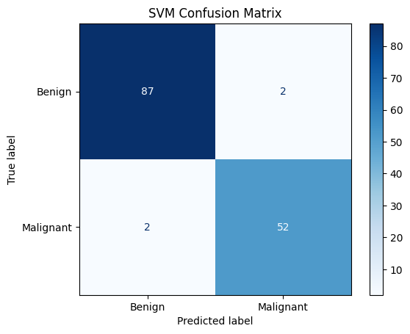
Figure A: SVM Model
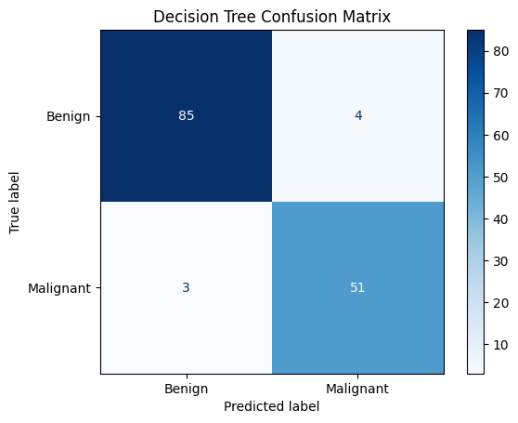
Figure B: Decision Tree (Tuned Parameters)
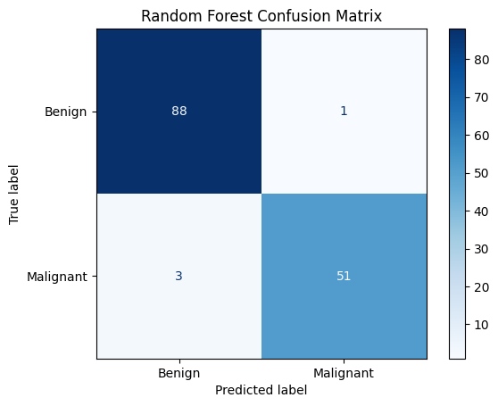
Figure C: Random Forest (Tuned Parameters)
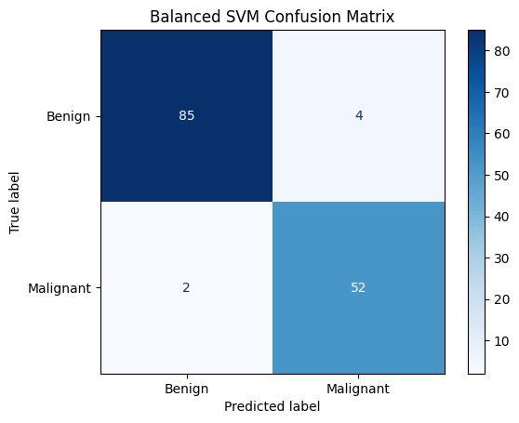
Figure D: SVM (Balanced)
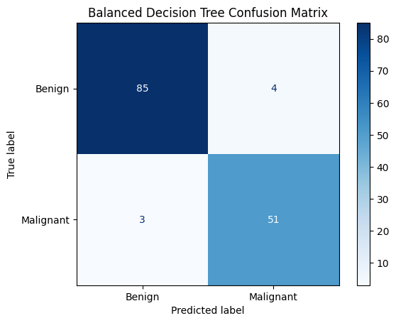
Figure E: Decision Tree (Balanced)
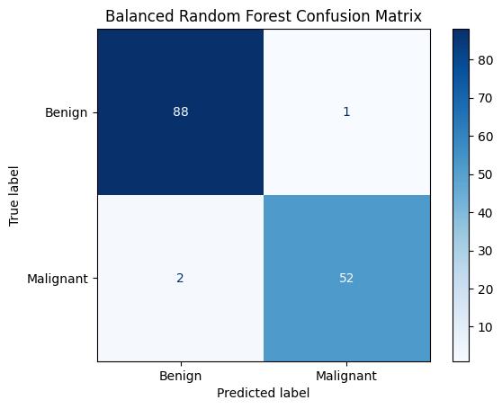
Figure F: Random Forest (Balanced)
Based on this, we can conclude that Random Forest (Balanced) has the best test accuracy, since it has only misclassified 3 data points.
D. Discussion
The experimental results reveal several key insights:
- SVM performs best on average out of all the models, with Random Forest being a close competitor.
- Using balanced class-weights improves the testing accuracy and recall of Random Forest.
E. Conclusion
This study shows that while the balanced Random Forest achieved the highest test-set accuracy and recall, the SVM demonstrated the most stable cross-validation performance. Although the Random Forest model performed strongly on the held-out test set, its lower cross-validation scores suggest that the test split may have been comparatively favorable. These findings indicate that cross-validation provides a more reliable estimate of model generalization. Furthermore, a larger dataset would likely improve the development of a more robust and generalized classification model.
REFERENCES
- Tsehay Admassu Assegie, Sushma S. J., A Support Vector Machine and Decision Tree Based Breast Cancer Prediction, International Journal of Engineering and Advanced Technology (IJEAT), ISSN: 2249 – 8958, Volume-9 Issue-3, February, 2020.

